.

“Variation Among Fitness-Related Traits in Different Butterfly Species in Comparison to Their Nutritional Intake”

Dr. Jonathan Mitchell

BIOL 461

5 April, 2022

Makayla Ball

Introduction

Over the course of time, an analytical framework known as the life-history theory has focused heavily on why variation occurs so widely in fitness-related traits among organisms (Snell‐Rood et al., 2015). Traits such as wing length and eye size in butterflies show a wide range of variation among species and some studies show that nutritional intake could be linked to variation in traits that impact fitness among butterfly species. One such example, nitrogen, is an essential nutrient for butterflies as it plays an important role in growth rates and competitive ability (Borer et al., 2013). This fundamental element can affect herbivore populations and make them function optimally when introduced to the appropriate amount, controlling the species diversity as well as species dynamics (Vitousek et al., 1997). Two variables being looked at in this study are eye width and wing length of butterflies. We are interested in the eye width of the butterflies because vision is an important factor for both male and female butterflies. For males, vision is an important aspect for whether or not he will find a mate (Rutowski et al., 2001). For females, vision is important for host finding, and both of these traits are important parts of fitness among these species (Papaj et al., 1987). Wing length was the other variable of interest, and it is being used as a measure of body size and is important for investment in maintenance, reproduction, and survival (Swanson et al., 2016).

In this study, multiple tests were performed to test whether or not the amount of nitrogen our butterfly species were receiving would have a positive correlation to eye width and wing length. First, two Pearson correlations were conducted among butterfly species to test the correlation between the variables of interest. Two Spearman’s correlations were also conducted as well as two Kendall’s correlations. The three types of correlation tests were run to confirm whether or not there was a correlation among the variables. Aside from the correlation tests, two X-Y Scatter plots were created to look at the variables of interest. We expect to see larger eye width and larger wing length for species that receive larger amounts of nitrogen intake.

Materials and Methods

*Data Collection*

Sampling was done for 96 butterfly species, and a total of 1,162 individuals. Field caught live species were taken from 11 different states from the United States and taken back to the laboratory in sealed containers until ready for dissection, and museum specimens were collected from the University of Minnesota Insect Collection Department of Entomology from 25 different states from the United States along with 6% of the specimens being from Canada, Central, and South America. Museum specimens collection dates ranged from 1899 to 2010. Eye width for museum specimens were measured by orienting the butterflies face-on under a microscope and measuring each eye as the distance from where the eye meets the head, to the furthest distance from the midline. Both eyes were measured as a way to ensure proper orientation of the species. Wing length on museum specimens were measured from the articulation of the forewing with the thorax to the wing apex. In field caught species, the eye width was measured the same as for museum specimens, and the wings were completely removed and placed flat for measuring following the same initial guidelines as the museum specimens.

Data on nitrogen in plants was obtained from an outside source (Borer et al., 2013). 117 host plants were collected for sampling from 8 different states among the United States, collections were based off of the percentage of nutrient content within the dried leaf samples. Plant nitrogen values were calculated at the family level and were averaged for all samples of the given family.The length of time species have been adapting to their present diet does not matter, which may suggest that nutrition could be a fundamental constraint on life-history evolution in some lineages (Swanson et al., 2016). A phylogenetic tree was constructed for all 96 species in this study using the “phytools” package in RStudio (RStudio Team, 2022). The tree of all butterfly species is shown in Figure 1.

*Correlation tests*

A series of correlation tests were performed in this study including two Pearson’s correlations, two Spearman’s correlations, and two Kendall’s correlations. We tested two separate variables in comparison to nitrogen intake for each type of correlation, resulting in a total of 6 correlations. The first correlation compared the correlation between nitrogen intake and average eye width among all species, this was done for each of the three types of correlations. The second correlation compared the nitrogen intake and average wing length among all species, which was also done for each of the three types of correlations. All correlations were performed using RStudio (RStudio Team, 2022).

*X-Y Scatter plot*

Two scatter plots were made using RStudio, both of which contained best fit lines. The first scatter plot was made to compare the nitrogen intake of species with the average eye width, while the second one was plotted to compare the nitrogen intake of species with the average wing length.

Results

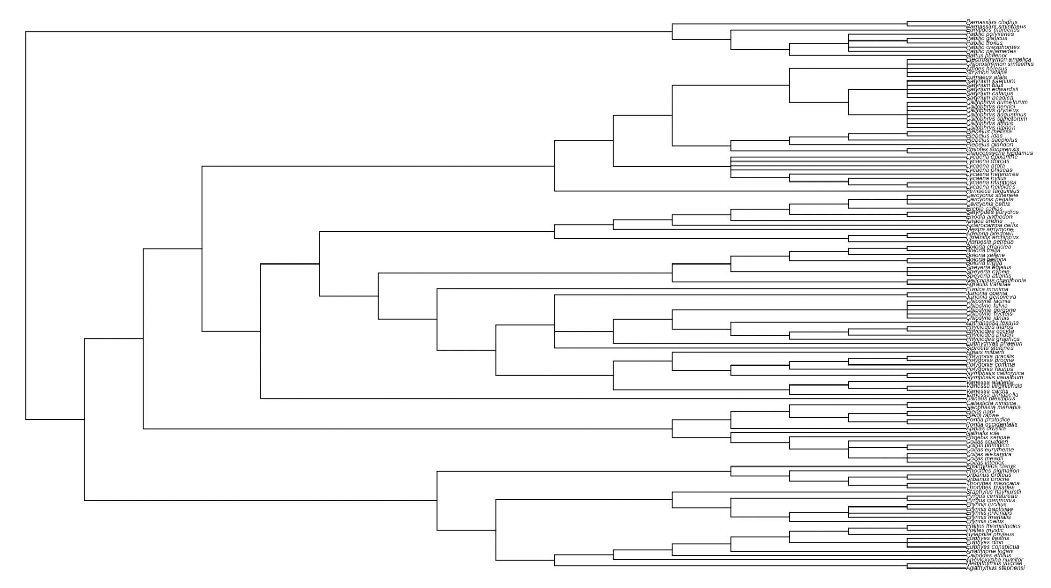

Figure 1: phylogenetic tree of all 96 butterfly species being tested in this study

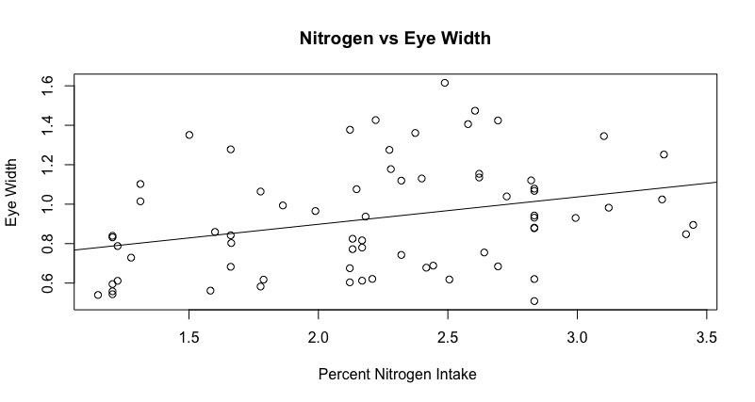

Figure 2: percent nitrogen intake in comparison to eye width of butterflies (R²= 0.09906, p-value= 0.00844).

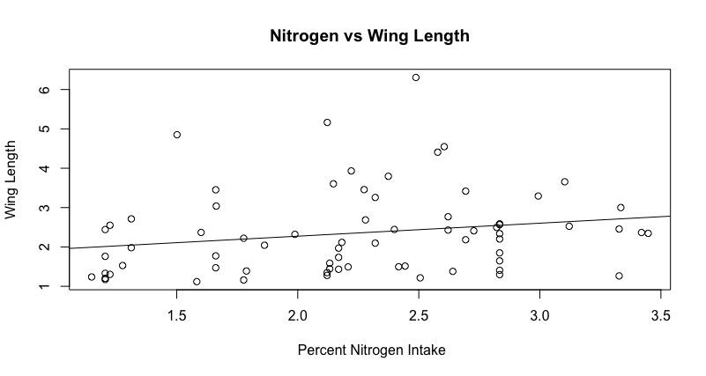

Figure 3: percent nitrogen intake in comparison to wing length of butterflies (R²= 0.03884, p-value= 0.102).

Correlation between percent nitrogen intake in comparison to eye width as calculated by the Pearson’s correlation showed a correlation value of 0.319819, while the Pearson’s correlation between percent nitrogen intake and wing length showed a correlation of 0.234036. Correlation values as calculated by Spearman’s correlation showed to be 0.3361879 for percent nitrogen intake in comparison to eye width, and 0.3115547 for percent nitrogen intake in comparison to wing length. Correlation values as calculated by Kendall's correlation showed results of 0.2203061 for percent nitrogen intake in comparison to eye width, and 0.2089666 for percent nitrogen intake in comparison to wing length. Figure 2 shows an X-Y scatter plot between percent nitrogen intake and eye width with an R² value of approximately 0.099 and a p-value of approximately 0.008. Figure 3 shows an X-Y scatter plot between percent nitrogen intake and wing length with an R² value of approximately 0.039 and a p-value of 0.102.

Discussion

After conducting our different correlations as well as X-Y scatter plots, our results show very minimal support for our original hypothesis. Our Pearson's correlation values for both tests were very low (0.319819 and 0.234036). To further support the low Pearson values, our Spearman values as well as our Kendall values also both showed weak correlations between our variables. These values indicate that although there was seen to be a positive correlation between nitrogen intake and eye width and wing length, these values were very weak and showed no significance between the two variables. Nitrogen intake did not have a significant impact on our variables. The same results can be interpreted from our scatter plots due to the low R² values as shown in figure 2 and figure 3. Having an R² value less than 0.1 indicates a weak effect, and both of the values were below that value (0.099 and 0.039). P-values for both plots were calculated and we found that when comparing nitrogen intake to eye width, our results were statistically significant since our value was approximately 0.008, meaning that these variables do have a weak correlation. When comparing nitrogen intake with wing length, we had a much larger p-value (0.102) that was not significant, meaning these two variables could be more correlated than we are seeing. Most of our results can confirm that even though nitrogen intake had some positive correlation on eye width and wing length, the correlations were way too small to have any meaningful effect on the butterfly species.

There are ways this study could have been altered and improved to show better results. One being altering the sampling methods. Instead of collecting butterfly species that were the easiest to collect data on, the study could have been more focused on butterfly species that cannot adapt to low nitrogen conditions. If some of our species were able to adapt to, or cope with low nitrogen conditions, their wing length and eye width may not be impacted by the amount of nitrogen they receive suggesting that nitrogen conditions in general may play a small role in life-history evolution (Douglas, 2009). Another alteration that could’ve been done in this study was to use the raw nitrogen values rather than using the average nitrogen values. This could be something that is considered in future studies that might offer different results. Overall, our results did show slight positive correlation between our variables, but the data observed did not have a strong enough correlation to confidently say these variables are related enough to support our hypothesis.

Literature Cited

Borer, E. T., Bracken, M. E., Seabloom, E. W., Smith, J. E., Cebrian, J., Cleland, E. E., Elser, J. J., Fagan, W. F., Gruner, D. S., Harpole, W. S., Hillebrand, H., Kerkhoff, A. J., & Ngai, J. T. (2013). Global biogeography of Autotroph Chemistry: Is insolation a driving force? *Oikos*, *122*(8), 1121–1130. https://doi.org/10.1111/j.1600-0706.2013.00465.x

Douglas, A. E. (2009). The microbial dimension in insect nutritional ecology. *Functional Ecology*, *23*(1), 38–47. https://doi.org/10.1111/j.1365-2435.2008.01442.x

Papaj, D. R., & Rausher, M. D. (1987). Components of conspecific host discrimination behavior in the Butterfly Battus Philenor. *Ecology*, *68*(2), 245–253. https://doi.org/10.2307/1939254

RStudio Team (2022). RStudio: Integrated Development Environment for R. RStudio, PBC, Boston, MA URL <http://www.rstudio.com/>

Rutowski, R., Demlong, M., & McCoy, L. (2001). Visual mate detection in a territorial male butterfly (Asterocampa Leilia): Effects of distance and perch location. *Behaviour*, *138*(1), 31–43. https://doi.org/10.1163/156853901750077772

Snell‐Rood, E., Cothran, R., Espeset, A., Jeyasingh, P., Hobbie, S., & Morehouse, N. I. (2015). Life‐History evolution in the anthropocene: Effects of increasing nutrients on traits and trade‐offs. *Evolutionary Applications*, *8*(7), 635–649. https://doi.org/10.1111/eva.12272

Swanson, E. M., Espeset, A., Mikati, I., Bolduc, I., Kulhanek, R., White, W. A., Kenzie, S., & Snell-Rood, E. C. (2016). Nutrition shapes life-history evolution across species. *Proceedings of the Royal Society B: Biological Sciences*, *283*(1834), 20152764. https://doi.org/10.1098/rspb.2015.2764

Vitousek, P. M., Aber, J. D., Howarth, R. W., Likens, G. E., Matson, P. A., Schindler, D. W., Schlesinger, W. H., & Tilman, D. G. (1997). Technical report: Human alteration of the global nitrogen cycle: Sources and consequences. *Ecological Applications*, *7*(3), 737. https://doi.org/10.2307/2269431